August 2025
Japan Electronics and Information Technology Industries Association

Report on the Responsible Minerals Sourcing Inquiry Briefings 2025

- Purpose
The briefing sessions were held to explain the background and latest relevant trends of responsible minerals sourcing to working level personnel of manufacturing companies, etc. in the supply chain that share similar challenges relating to responsible minerals sourcing survey and due diligence, and deepen their understanding on the importance of the survey and due diligence.

- Organizer
The Education and PR Team of JEITA Responsible Minerals Trade Working Group

- Schedule
 | Date/Time |  | Form | Individual Consultations
Tokyo ① | June 26 (Thu.) | 14:00  -  16:15 | Hybrid  (WEB + on-site) | Conducted at each site after the briefing session  (30 minutes max)
Tokyo ② | June 27 (Fri.)
Nagoya | July 3 (Thu.) |  | On-site
Osaka | July 4 (Fri.)

- Program of the Inquiry Briefing:
Part 1  14:00 - 15:30 | Opening Speech (approx. 5 min.)
Background and latest trends of “Responsible Minerals Sourcing” (approx. 30min.)
Member of the Education and PR Team, JEITA Responsible Minerals Trade Working Group
RMAP and Due Diligence (DD) Efforts of Downstream Companies (approx. 45min.)
Member of the Education and PR Team, JEITA Responsible Minerals Trade Working Group
Rest Break (layout change)
Part 2  15:45 - 16:15  (on-site only) | Panel Discussion (approx. 30 min.)  “Administrative Work regarding Surveys for Downstream Companies”  Member of the Education and PR Team, JEITA Responsible Minerals Trade Working Group
Individual consultations were conducted after briefing sessions (only for participants attending on-site)

- Number of Participants
 | Date/Time | Number of Participants |  |  | Reference  (Number of Participating Companies)
 |  | Participation on-site | Participation by WEB | Total
Tokyo ① | June 26 (Thu.) | 92 | 1,601 | 1,693 | 1,400 companies  (approx.)
Tokyo ② | June 27 (Fri.) | 138 | 1,035 | 1,173
Nagoya | July 3 (Thu.) | 59 |  | 59
Osaka | July 4 (Fri.) | 124 |  | 124
Final Total |  | 413 | 2,636 | 3,049

- Outline Report
Companies have conducted “Conflict Minerals Survey” ever since the enactment, in July 2010, of Section 1502 (the Conflict Minerals Provision) of the Dodd-Frank Wall Street Reform and Consumer Protection Act (Dodd-Frank Act) in which manufacturers and certain other companies listed on the U.S. stock exchanges were required to file reports on conflict minerals (tin, tantalum, tungsten, and gold) and disclose relevant information to the U.S. Securities and Exchange Commission (SEC). However, due to the “EU Conflict Minerals Regulation” ,“EU Battery Regulation” and other changes in environment, the scope of minerals, areas and risks that should be taken into consideration by companies at the time of mineral sourcing, as part of the actions regarding “Responsible Mineral Sourcing”, have expanded, making it necessary to further examine future measures taking into consideration such trends.
In the context of the above, the Responsible Minerals Trade Working Group (Working Group) has, again this year, hosted Responsible Minerals Sourcing Inquiry Briefings in order to assist manufacturing companies in the supply chain that share similar challenges. At the briefings, the presenters (members of the Working Group) explained the background of why it became necessary to take actions regarding “Responsible Minerals Sourcing”, trends of regulations and other trends that have impact on the survey and due diligence activities, and administrative work regarding due diligence taken by downstream companies. Also, a panel discussion on the topic of “Administrative Work regarding Surveys to be conducted by Downstream Companies” was conducted at the briefings.
In addition, to contribute to companies dealing with responsible minerals sourcing, individual consultations were conducted by the presenters at each site after the briefing session.

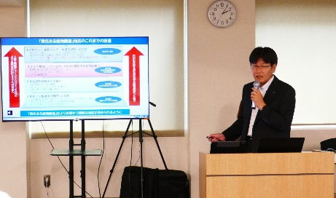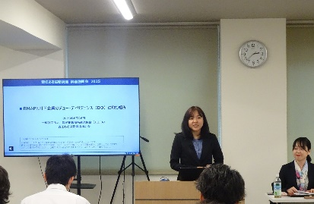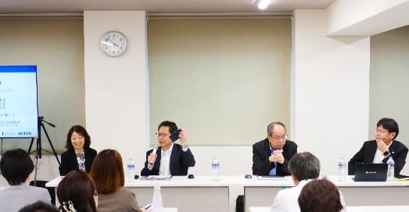
Tokyo① | Tokyo② | Panel Discussion

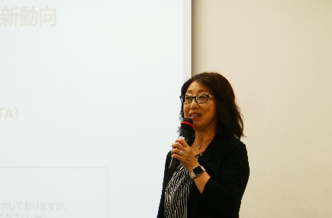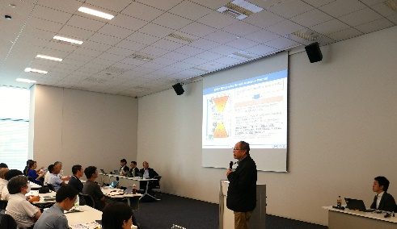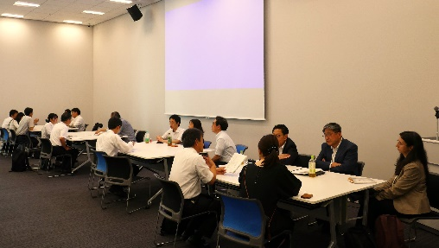
Nagoya | Osaka | Individual Consultation

- Administration/Preparation
 | Tokyo ① | Tokyo ② | Nagoya | Osaka
Facilitator | Toshiba Corporation. | Hitachi, Ltd. | Makita Corporation. | ROHM Co., Ltd.
Presenter | Sharp Corporation  Murata Manufacturing Co., Ltd. | TDK Corporation  Nikon Corporation | Panasonic Industry Co., Ltd.  Murata Manufacturing Co., Ltd. | Sumitomo Electric Device Innovations  Murata Manufacturing Co., Ltd.
Panel Discussion | <Moderator>  Panasonic Industry Co., Ltd.  <Panelist>  Kyocera Corporation  Sharp Corporation  Murata Manufacturing Co., Ltd. | <Moderator>  Panasonic Industry Co., Ltd.  <Panelist>  Kyocera Corporation  TDK Corporation  Murata Manufacturing Co., Ltd. | <Moderator>  Sharp Corporation  <Panelist>  Murata Manufacturing Co., Ltd.  Kyocera Corporation  Makita Corporation  Nikon Corporation | <Moderator>  Sharp Corporation  <Panelist>  Murata Manufacturing Co., Ltd.  Kyocera Corporation  Panasonic Industry Co., Ltd.  ROHM Co., Ltd.  Shimadzu Corporation
In addition to the above companies, Canon Inc. , KOA Corporation , Pioneer Corporation , Taiyo Yuden Co., Ltd. ,
Alps Alpine Co., Ltd. , OMRON Corporation , KONICA MINOLTA, INC. , Nippon Chemi-Con Corporation ,
NEC Corporation , Fujitsu Limited , Renesas Electronics Corporation , and Japan Aviation Electronics Industry, Limited participated in the preparation of these briefing sessions.

